# **Trend analysis**

**Features used:**

* ORG code
* Amazon order id
* Merchant order id
* Purchase date
* Fulfillment channel
* Sales channel
* Product name
* Sku
* Asin
* Item status
* Quantity
* Currency
* Item price
* Ship city
* Ship state
* Ship postal code
* Ship country

**Data preprocessing:**

Total records: 851896

Total records after data preprocessing:804361

**Analysis:**

Adding the sales amount by grouping with month.

df['Month']=pd.DatetimeIndex(data['purchase_date']).month

df['Sales'] = df['quantity']* df['item_price']

df.groupby(['Month']).sum()

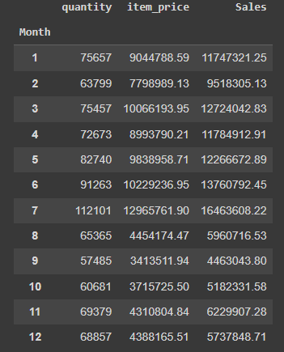

Adding the sales amount by grouping with month.

df['Year']=pd.DatetimeIndex(data['purchase_date']).year

df.groupby(['Year']).sum()

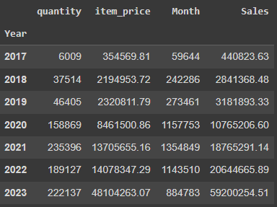

**Visualization:**

Bar plot:

Highest number of sales in a month

months = range(1,13)

print(months)

plt.bar(months,df.groupby(['Month']).sum()['Sales'])

plt.xticks(months)

plt.ylabel('Sales')

plt.xlabel('Months')

plt.show()

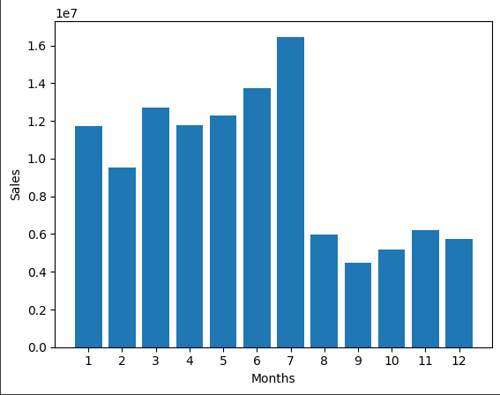

Highest number of sales in a year

x=list(set(df['Year']))

plt.bar(x,df.groupby(['Year']).sum()['Sales'])

plt.xticks(x)

plt.ylabel('Sales')

plt.xlabel('Year')

plt.show()

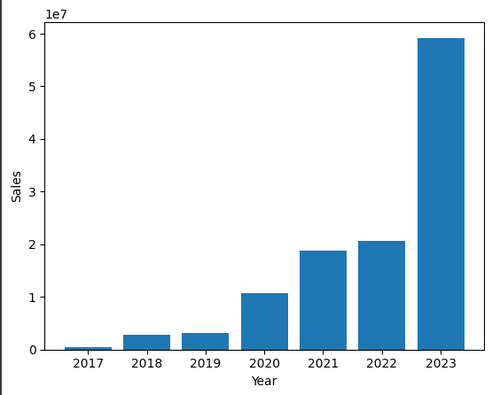

Highest number of sales in the countries

plt.subplots(figsize=(20,9))

keys = [ship_country for ship_country, df in

df.groupby(['ship_country'])]

plt.bar(keys,df.groupby(['ship_country']).sum()['Sales']

plt.ylabel('Sales')

plt.xlabel('countries')

plt.xticks(keys, rotation='vertical',size='9')

plt.ylim([1, 600])

plt.show()

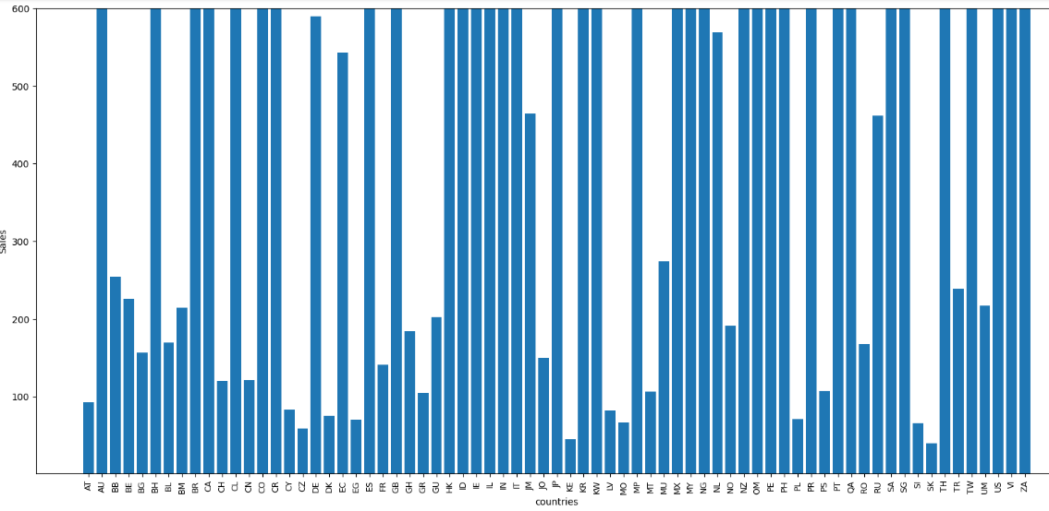

Highest number of sales in the cities

plt.subplots(figsize=(50,20))

keys1 = [ship_city for ship_city, df in

df.groupby(['ship_city'])]

plt.bar(keys1,df.groupby(['ship_city']).sum()['Sales'])

plt.ylabel('Sales')

plt.xlabel('cities')

plt.xticks(keys1[::200], rotation='vertical',size='6')

plt.ylim([0,300])

plt.show()

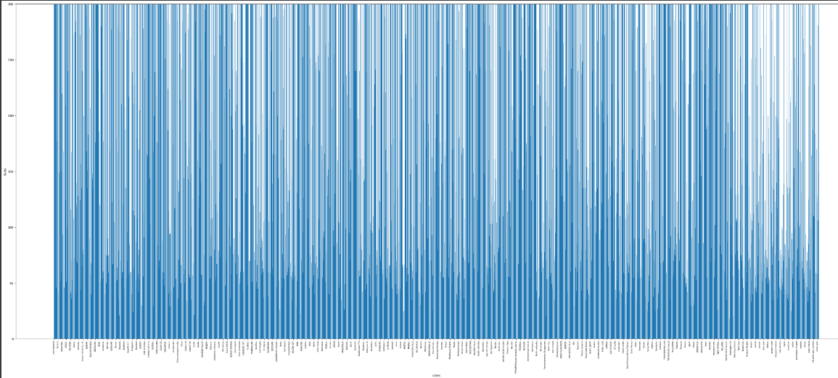

Streamlit:

Model which displays the analysis graph.

